TOPIC: Parents Struggle to Track Children’s Learning Progress

NAME: Sonavi K
REGISTER NUMBER: 24BEIS122

Step 1: Observation
The observation was conducted in an educational context involving undergraduate and school students and their interaction with parents regarding academic progress. Observations were made through direct interaction with students and by analyzing survey responses collected digitally.
Key Observations
- Parents frequently ask students about their academic performance, but the understanding is often partial or unclear.
- Students usually explain their progress verbally, which may lead to miscommunication.
- Report cards and parent–teacher meetings are the primary formal sources of information.
- Some students feel misunderstood by their parents regarding performance and effort.
- Digital sharing of learning progress is acceptable to many students, but not all feel fully comfortable.
Observed Issues
- Delay in performance feedback
- Lack of continuous progress tracking
- Dependence on periodic evaluations (exams, report cards)
- Emotional stress due to misunderstanding

Step 2: User Identification (Stakeholders)
User Groups
- Students
  - Role: Primary learners
  - Expectations: Fair understanding of effort, reduced pressure, clear communication
- Parents
  - Role: Academic monitors and supporters
  - Expectations: Clear, timely, and accurate information about progress
- Educational Institutions (Teachers/Colleges)
  - Role: Evaluators and information providers
  - Expectations: Structured reporting, reduced communication gaps
3. Interviews / Survey
A survey with open-ended and closed-ended questions was conducted with more than 30 respondents, mainly undergraduate students.
Sample Questions
- What class/grade are you currently studying in?
- Mode of learning?
- Do your parents regularly ask about your studies?
- Do you think your parents clearly understand your academic process ?
- How do your parents usually know about your performance?
- Have you ever felt misunderstood by your parents about your academic performance?
- Would you be comfortable sharing your learning progress digitally with your parents?
Key Insights
- Majority of parents rely on students’ explanations and report cards.
- Many students feel parents understand their progress, but some report occasional misunderstandings.
- Digital sharing of progress is widely accepted but still uncertain for some users.
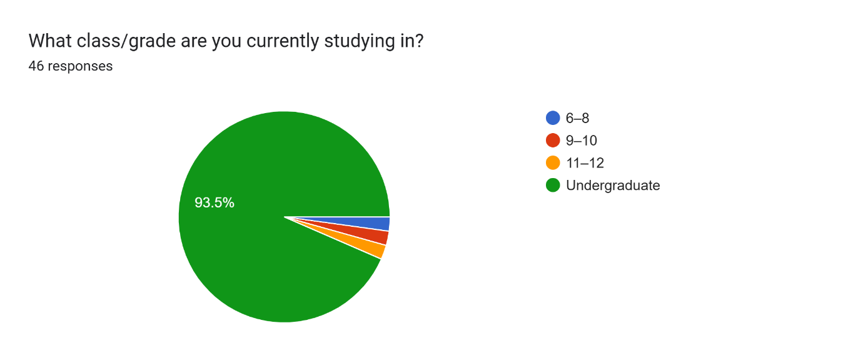
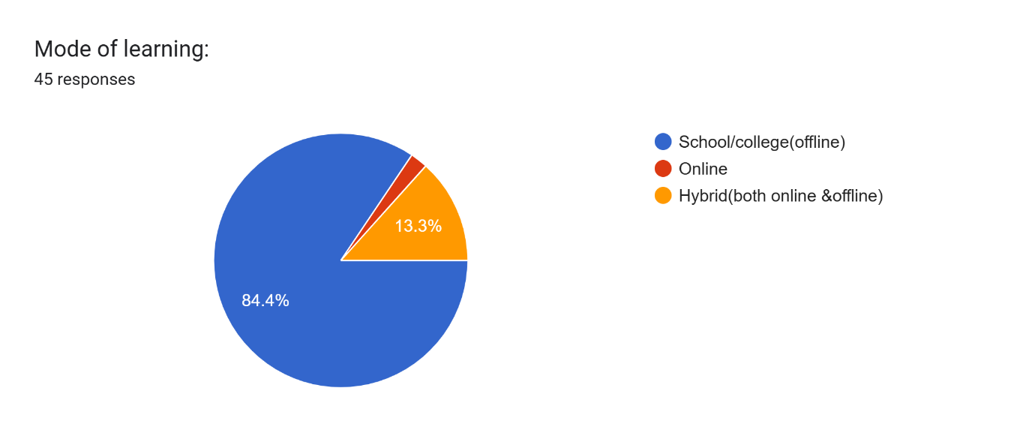

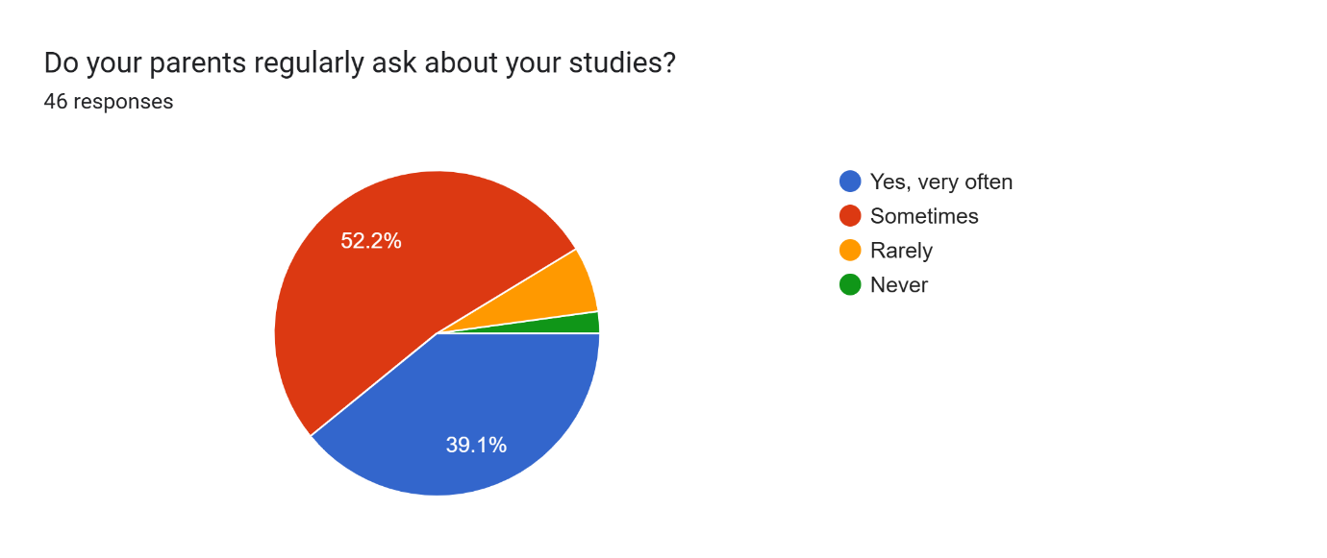
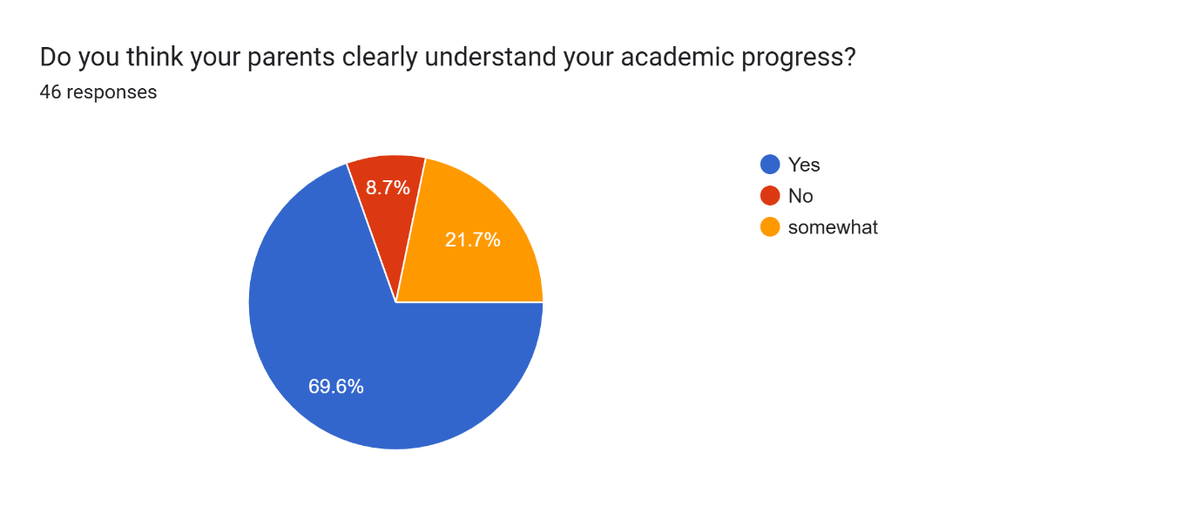

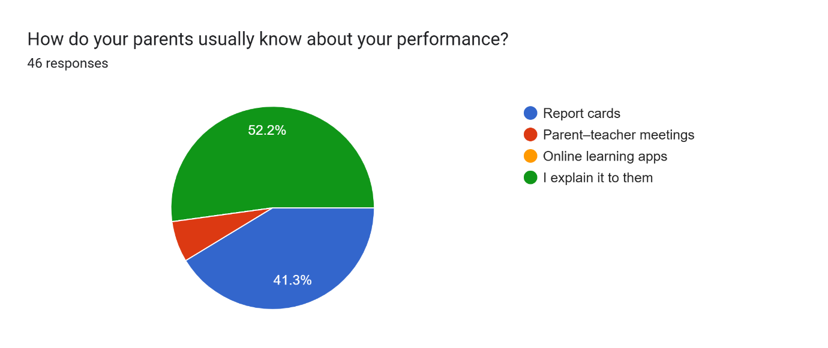
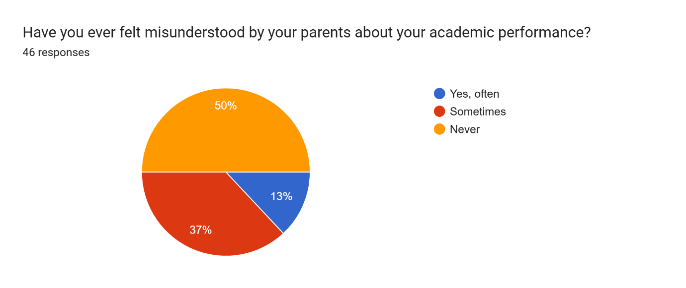
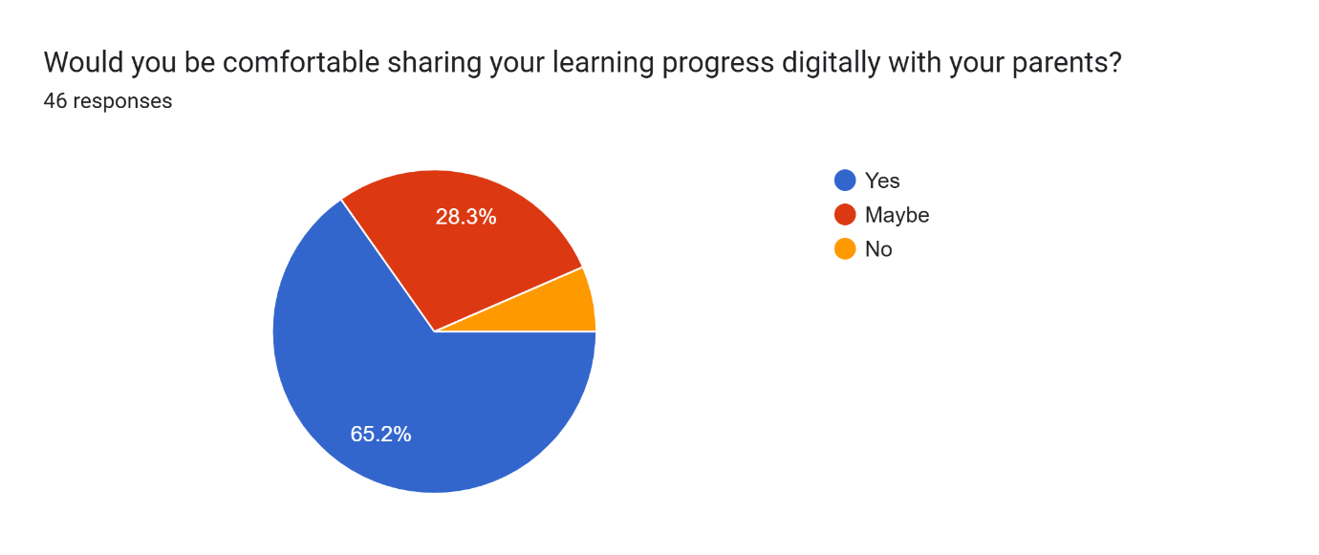

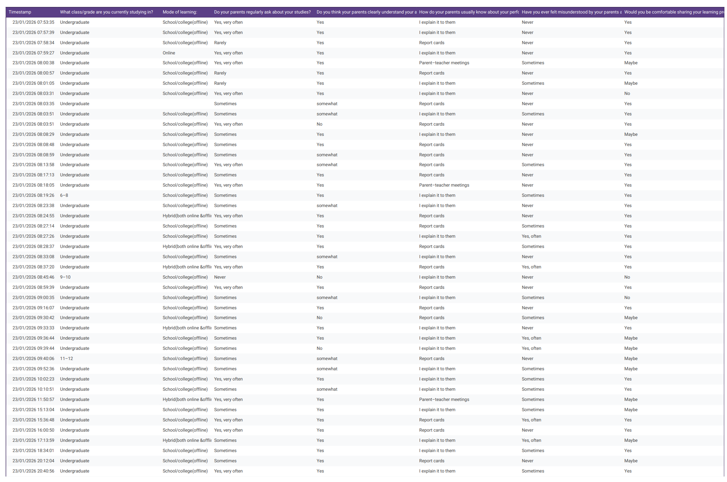

Step 4: Pain-Point Analysis
Category | Pain Points
Functional | No real-time progress tracking, delayed feedback
Emotional | Stress, pressure, feeling misunderstood
Systemic | Lack of transparent communication systems
Critical Pain Point
Parents do not have continuous and clear visibility into students’ learning progress.

Step 5: Root Cause Identification (5-Why Analysis)
Problem: Parents struggle to track children’s learning progress.
- Why? → Information is shared irregularly.
- Why? → Dependence on exams and report cards.
- Why? → Lack of ongoing assessment visibility.
- Why? → No centralized digital tracking system.
- Why? → Traditional education systems focus on summative evaluation.
Root Causes
- Absence of real-time academic tracking tools
- Over-reliance on periodic assessments
- Limited parent–student–teacher communication channels

Step 6: Wicked Problem Understanding
This problem can be classified as a wicked problem because:
- Multiple stakeholders are involved (students, parents, institutions).
- Stakeholder needs conflict (privacy vs monitoring).
- No single solution fits all educational levels.
- Social, emotional, and technological factors are interconnected.
Improving transparency may increase pressure on students, while reducing monitoring may worry parents.

Step 7: Reflection
1. What assumptions were incorrect?
Initially, it was assumed that parents clearly understand their children’s academic progress through regular conversations, report cards, and parent–teacher meetings. This assumption was incorrect because many parents rely on incomplete or delayed information, and students’ verbal explanations often lead to misunderstandings and emotional stress.

2. How did user perspectives change your understanding?
User perspectives—especially from students—revealed that communication gaps are common and that parents may misinterpret effort and performance. This helped shift the understanding from a surface-level communication issue to a deeper problem involving emotional stress, lack of real-time tracking, and system-level limitations.

3. Why is jumping to solutions risky?
Jumping directly to solutions without understanding root causes can lead to ineffective or even harmful outcomes. For example, introducing strict monitoring tools without considering student privacy could increase pressure and stress. Proper analysis ensures solutions are user-centered and address the real problem, not just symptoms.

4. What skills did you develop through this lab?
Through this lab, the following skills were developed:
- Observation and problem identification
- Stakeholder and user analysis
- Survey and interview design
- Pain-point and root-cause analysis (5-Why method)
- Empathy and user-centered thinking
- Critical thinking and reflection

